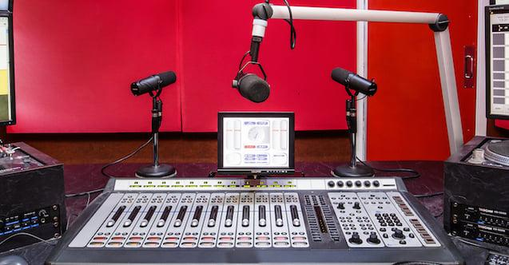

**Seeking Expressions of Interest for Breaking Sound Barriers with RTRFM**RTRFM is seeking expressions of interest for a project that will train participants in how to present and produce radio and podcast content. This project is specifically aimed at people in the community who identify as having a disability.

The name of this course is ‘Breaking Sound Barriers’, and it was previously delivered in 2023. We are now seeking 7 new students from a diversity of backgrounds who would benefit from training. All graduates will produce a short podcast episode to be featured through RTRFM’s platforms (on the radio at the frequency 92.1FM and online at rtrfm.com.au).

We are excited and dedicated to sharing your stories, as part of our Disability Inclusion Plan. [https://rtrfm.com.au/rtrfm-disability-inclusion-plan](https://rtrfm.com.au/rtrfm-disability-inclusion-plan/)

Participation in ‘Breaking Sound Barriers’ will require around 2 hours a fortnight for 12 weeks, between April – June 2025.

This training program is free for participants, thanks to support from **Youth Disability Advocacy Network** and **Synergy.**   
  
To be considered for Breaking Sound Barriers (and help us customise the course) please answer the questions below.

You are welcome to email your response in writing or as a voice note to [breakingbarriers@rtrfm.com.au](mailto:breakingbarriers@rtrfm.com.au) or submit your expression of interest over the phone by calling 08 9260 9214. Audio or written applications are equally welcome.  
  
**Name:**   
**Age:**   
**Suburb:**

**Do you have any previous experience in radio or podcasting?** YES / NO

**Are you generally available on weeknights OR weekends?**

**This course is aimed at people with a diverse range of disabilities. We are committed to supporting you to access this course in ways that make you comfortable. Please select any options from the following list that what would help you engage in the course. There is also space at the end to let us know any additional access needs.**

* Wheelchair accessible venue
* Have opportunities to use an interpreter, text or type my answers.
* Learning Resources with simple text and images
* Learning resources in Audio format

**Please tell us anything else you’d like us to know here:**

Please feel free to get in touch if you have any questions.

**Deadline:** Friday, February 21, 2025

**Submit your Expression of Interest to:** breakingbarriers@rtrfm.com.au

**You can also verbally express interest by calling:** 08 9260 9214

Breaking Sound Barriers is delivered by:

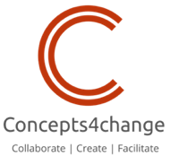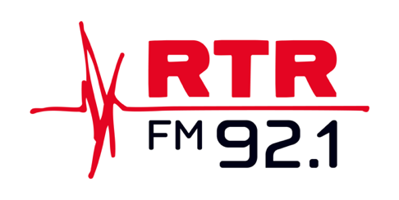

Breaking Sound Barriers is supported by:

