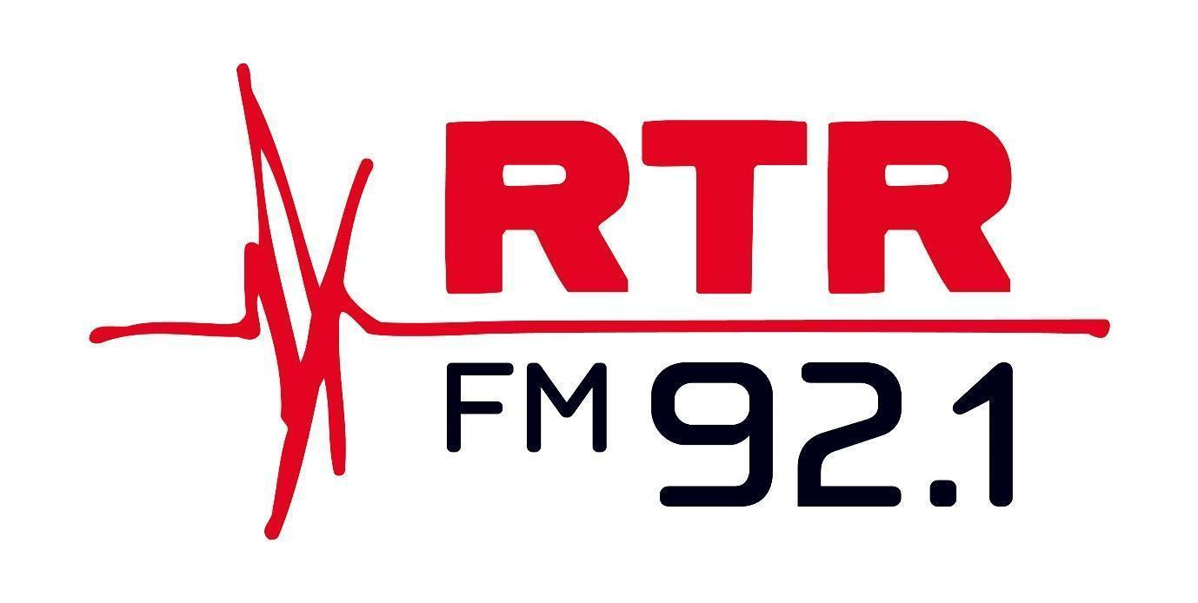

Disability Inclusion Plan 2.0

2026 - 2028

This Plan is available in the following alternative formats:
- Large print (PDF and Word versions)
- Easy Read document (PDF and Word versions)
- Audio

Why this matters to RTRFM

Despite strong anti-discrimination laws in place, people with disability are among the most marginalised groups in our community and experience multiple forms of discrimination and exclusion.

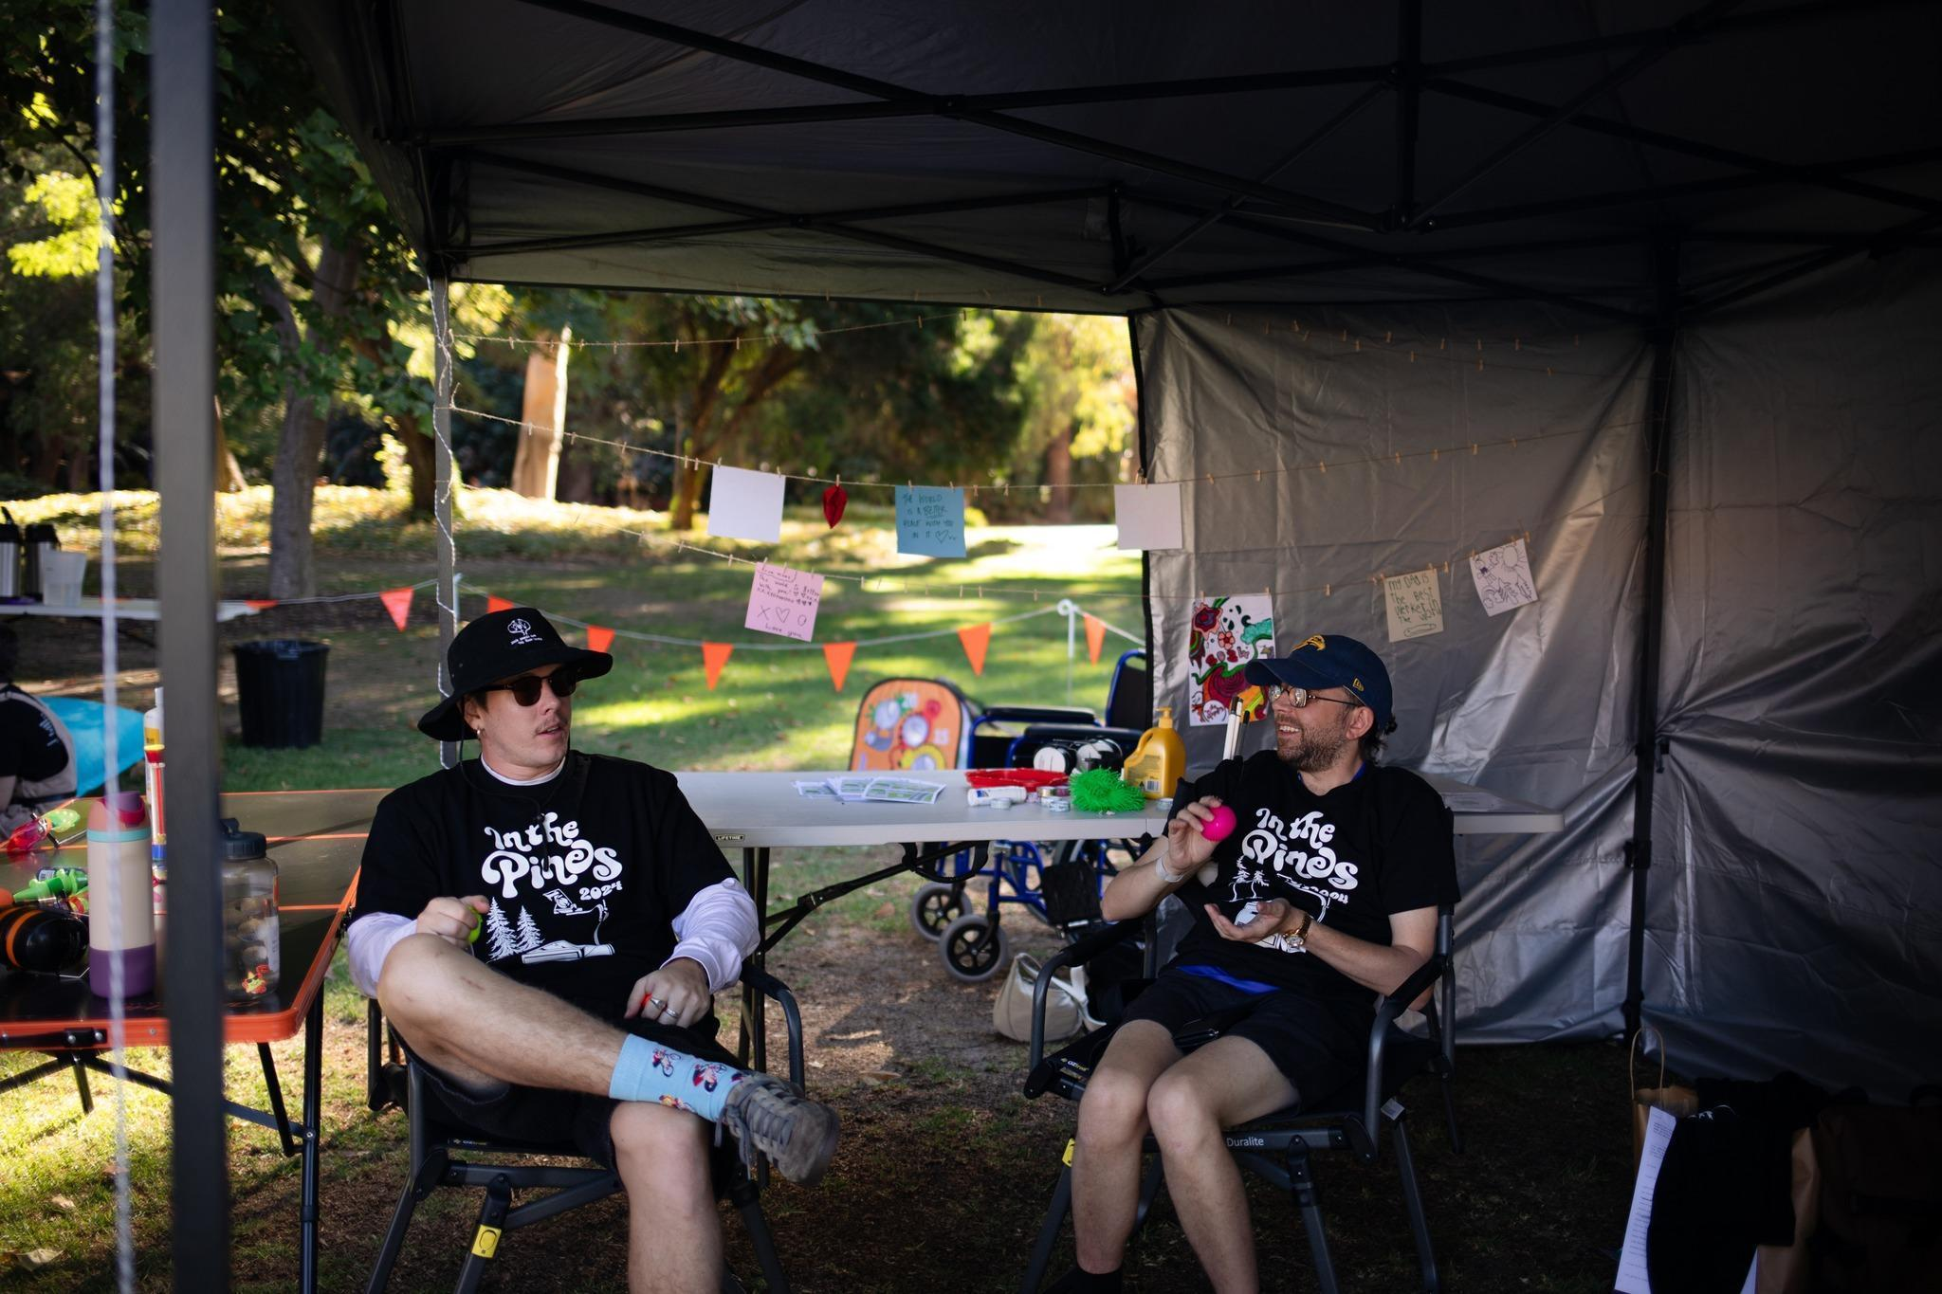
The role of allies and organisations with voice and influence, such as RTRFM, can be essential to help reduce barriers and experiences of discrimination, providing meaningful opportunities to participate fully in mainstream environments.
Communities that embrace diversity, creative expression and cultural activity are known to be richer and stronger. There has been much evidence of people participating in community-based arts that note an increase in their overall wellbeing, decreased feelings of isolation, more frequent communication and greater confidence.
RTRFM is proud to have established a strong reputation within Western Australia and has been striving to create a diverse community of passionate music and arts lovers for nearly half a century. As a free service, RTRFM encourages a strong sense of belonging for the Perth community, as anyone, no matter their status or demographic, can freely access the content provided.

With more than 125,000 weekly listeners, the station has successfully created a welcoming and inclusive community with a focus on arts, culture, social justice, politics and the environment. It acts as an advocate and voice for marginalised people, and this Plan represents this commitment to make sure there is greater participation and engagement from people with disability in all that RTRFM does.

Our journey so far

Watch a video that tells the story of our access and inclusion journey here!

In late 2021, RTRFM formed the Disability Inclusion Advisory Group (DIAG) to help guide the station, programming and events in its efforts to become even more inclusive and accessible. This coincided with the launch of our Community Broadcasting Association of Australia award-winning Breaking Sound Barriers initiative, providing podcasting and broadcasting training to people with disability.
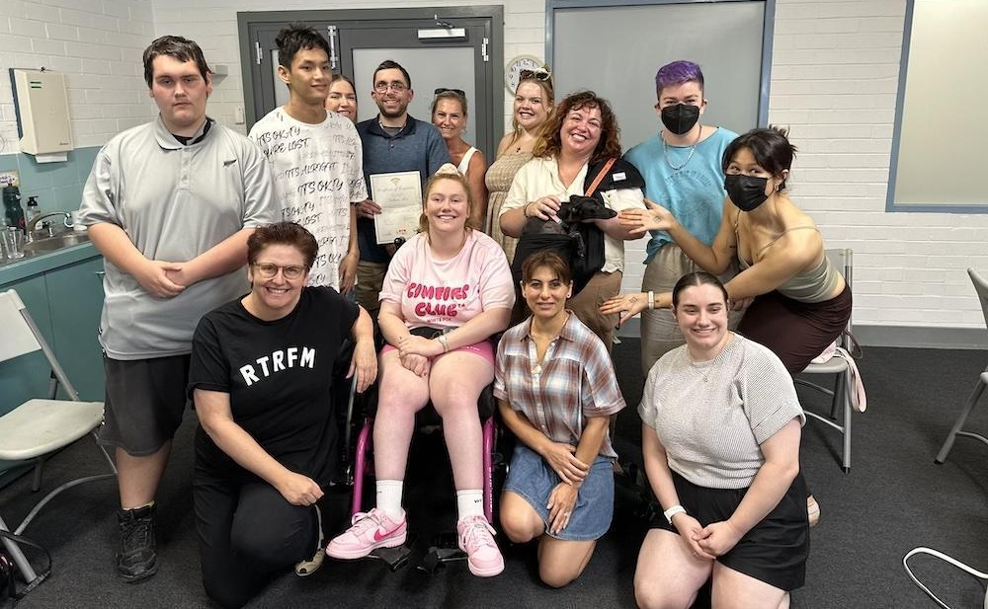
The inaugural DIAG helped produce RTRFM’s first Disability Inclusion Plan (2022 - 2024).

Since then, the station has implemented many actions contained in the plan, including:

- Promoting free entry to RTRFM events for Companion Card holders.
- Prioritising disability access at live music fundraisers.
- Including captioning on our published videos.
- Providing disability awareness training for staff.
- Hosting three rounds of Breaking Sound Barriers across 2021 – 2025, which was championed on POWERD media.
- Hosting International Day of People with Disability events in 2023, 2024 and 2025, with financial support from Developmental Disability WA.
- Undergoing a complete overhaul of our website, which included updating accessibility to minimum level WCGA AA; this was supported by regular and iterative feedback from the DIAG during the new site’s development and rollout. (NB: Our new and more accessible website, designed by Start Digital and launched in 2024, even won an internationally-recognised Webby for Best Music Website.)
- Launching the ‘Sensory Space’ at In the Pines 2024, which continued into 2025.
- Participating on the ‘Justice, Equity, Diversity and Inclusion at Your Station’ panel at the Community Broadcasting Association of Australia conference in 2024.
- Writing letters of support for Youth Disability Advocacy Network (YDAN) and Developmental Disability WA (DDWA) to Minister of Disability Services Don Punch after threatened cuts by the state government.
- Continuing to deliver content and shows that raise awareness of people with disability including the Breaking Sound Barriers pilot ‘Unapologetically Disabled’; the RTR2 residency by Crip Rave Theory; a sports segment on Breakfast with Pam co-hosted by former Breaking Sound Barriers graduate and DIAG member Nathan Moir; the showcasing of podcasts by DADAA participants on our show On the Record; and the consistent platforming of musicians with disability.
- Another former DIAG member, Simon Chong, now has a show on Vision Australia called Disability In Action, which was piloted on RTRFM and initially recorded from our studios. It won Best New Program at the 2025 Community Broadcasting Awards.

Though the make-up of the DIAG has changed over the years, it remains an important pillar of the RTRFM community, alongside our Reconciliation Action Plan (RAP) Working Group, which launched in 2024. The Community Broadcasting Association of Australia (CBAA) confirmed that RTRFM is, as of 2025, likely the only community station in the country with both a DIP and a RAP, making us a trailblazer in the sector.

At the conclusion of the first DIP’s timeline, RTRFM conducted an internal and external evaluation of its progress against key milestones and targets (with the mechanism for feedback co-designed with the DIAG). There are still plenty of opportunities, as well as barriers to overcome, and this updated Disability Inclusion Plan, once again co-designed with the DIAG, points to the next stage of our journey, taking us right up to our 50th anniversary.

Testimonial - Simon Chong

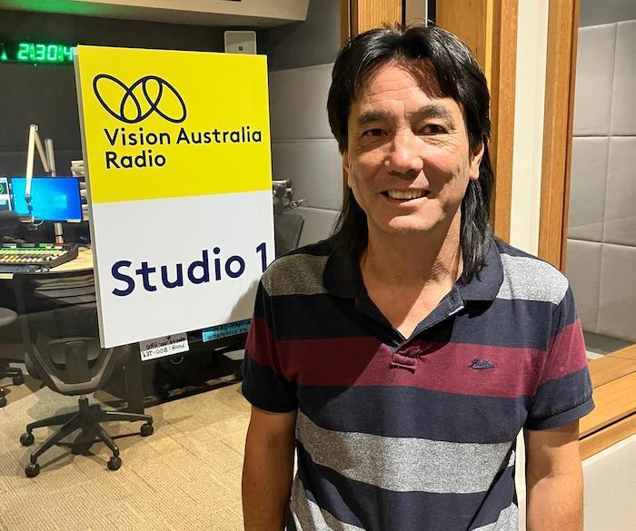
I was very pleased and honoured to be asked to join RTRFM’s Disability Inclusion Advisory Group several years ago. I have been a long-time Disability Advocate and have worked with many organisations, including several City Councils on similar disability reference groups or disability inclusion & access groups. But I found with the leadership from RTRFM’s General Manager, Board & other leading disability inclusion consultants involved, this was and still is a top ranking and sincere group.

I have always been a fan and keen listener to RTRFM and was excited to participate in this project. Obviously, RTR’s main function is to broadcast high quality radio, and they do that very well. But as an active member of the community, RTRFM is more than a radio station. It is a representative of our community and realised that it also had to be a leader in the community and demonstrate true diversity and inclusion at all levels and aspects of the organisation.

I was truly impressed and very proud to be part of this group and supportive organisation.

RTR also gave me an opportunity to try my hand at creating and broadcasting a segment within one of their programs. Not only was this very exciting and a lot of fun, it also gave me the confidence and skill to seriously pursue my own radio career. I am now working on a show with Vision Australia, producing and conducting a weekly interview program. I was recently honoured to win ‘Best New Program’ at the 2025 Community Broadcasting Association of Australia’s Awards. I would like to thank the team at RTRFM for their support and encouragement, which helped me get to this point.

The great thing about this fabulous radio station is that they do this for many people and are a great champion for those with a disability, and promoting disability rights and equality.

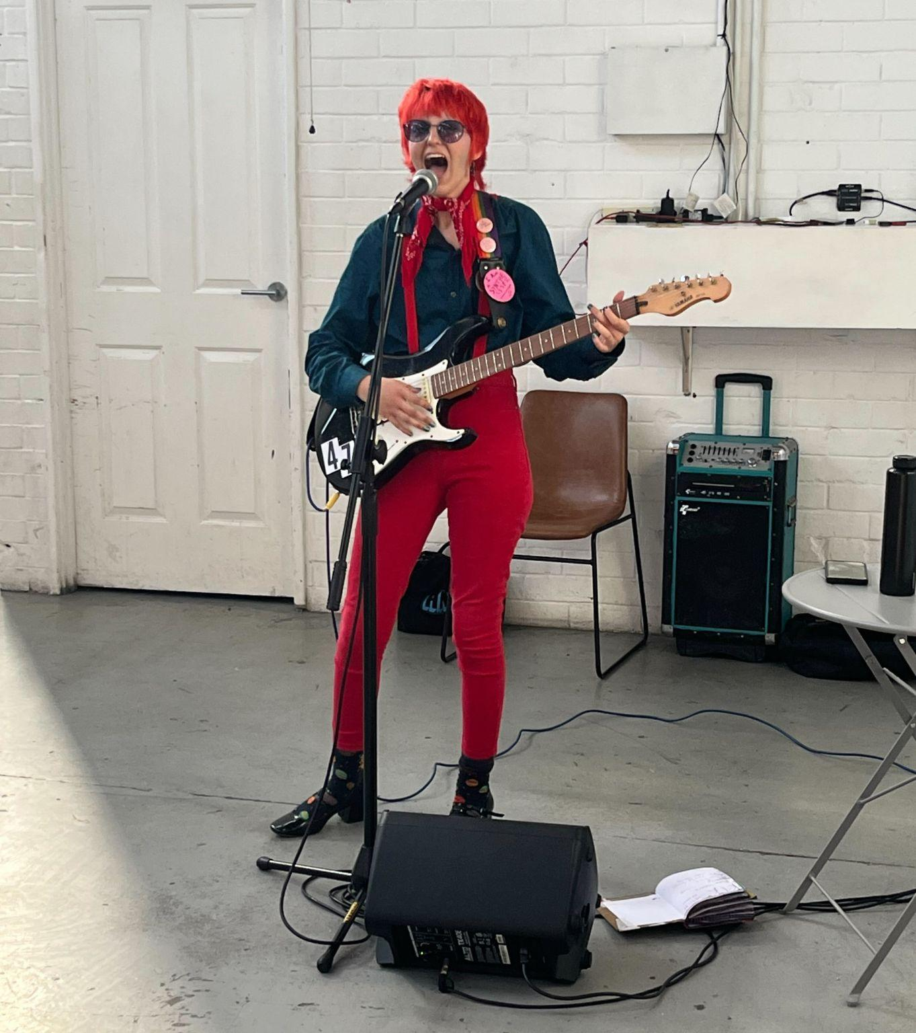
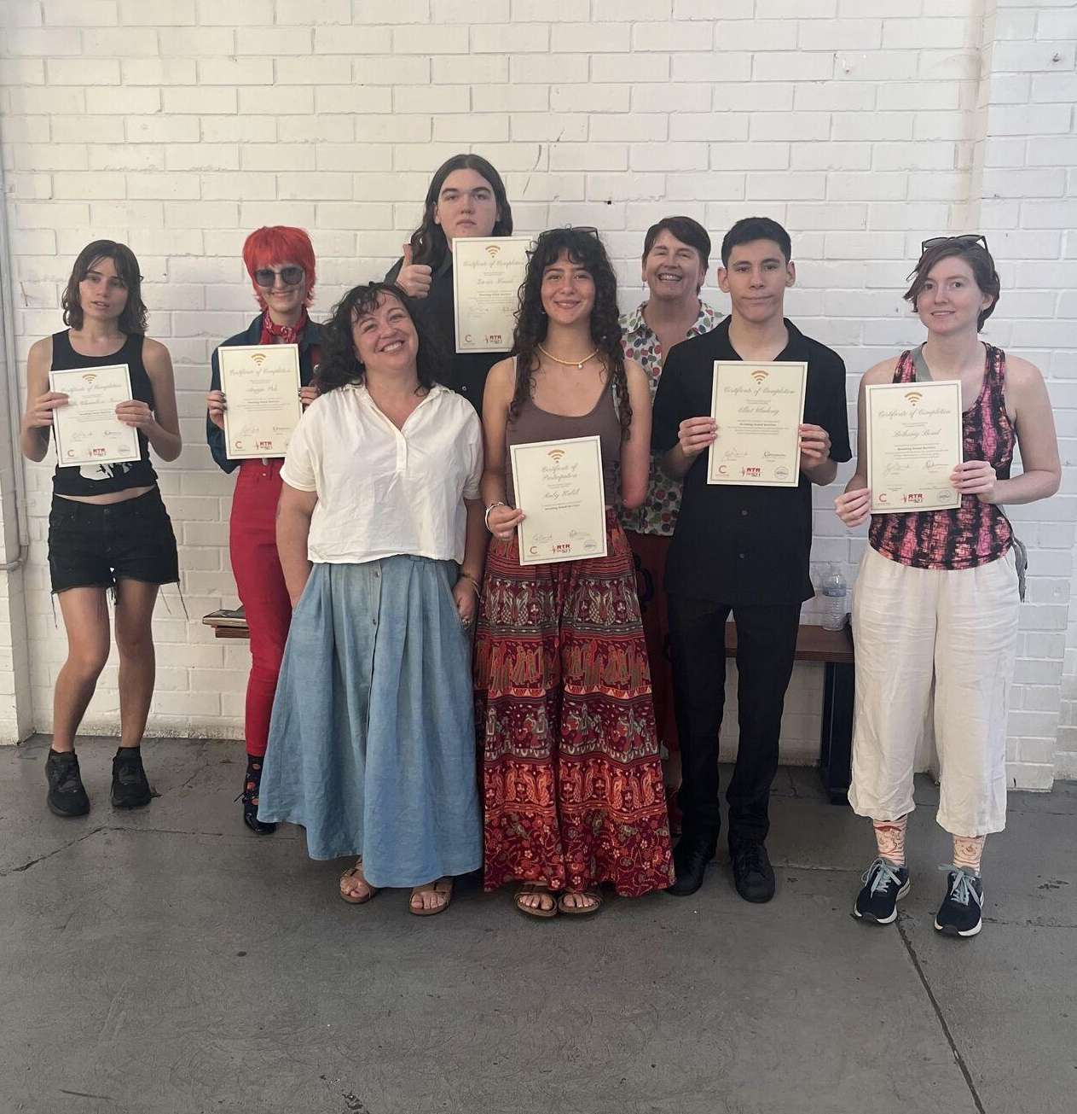
Our plan

Our Disability Inclusion Plans (DIPs) are developed through a co-design approach, following engagement and consultation with the broader community (specifically those with disability as well as disability-involving organisations).

This engagement aims to connect RTRFM with the disability community, increasing awareness of RTRFM as well as informing and collaborating on the design and implementation of actions contained in the DIP. As an outcome, we strive for an increase in people with disability and their peers participating in all that RTRFM does.

The Plan is intended to act as a living document that will be adjusted and amended based upon ongoing feedback, engagement and consultation. It will provide a practical roadmap towards improved inclusion and accessibility at RTRFM, informing the station’s Strategic Plan to ensure the station continues its mission to be a welcoming and respectful radio station, especially for people with disability/disabilities.

RTRFM thanks all members of the DIAG (past and present) for their work and support thus far, as well as key collaborator For Inclusion Consulting, and we thank the wider public for their patience and collaboration as we aim to make our community ever more accepting.

Disability Inclusion Advisory Group members (2022 - 2025):

Adele Aria, Adeniyi Adegboye, Alana Hunt, Andrew Dewberry, Anthony Pyle, Arye Jay Thompson, Bri Clark, Claire Pannell, Danika Potter, Eddie Curtis, Eleanor Ingram, James Fabri, Jane Armstrong, Jasmin Ely, Jason Bodle, Jayde Baldock, Jen Macauley, Jessica Carlton, John Hines, Joseph Wilkie, Joss Morgan, Julia Rose Bak, Kailyn Crabbe, Kat Tan, Kelly Campbell, Kristyanne Rung, Lauren Curtis, Louise Bodle, Maxine Drake, Sarah Arnason, Simon Chong, Siyat Abdi, Will Jones.

Theme 1: Open and respectful environment

Objectives:
- Increase representation and visibility of volunteers, presenters and staff with disability at RTRFM, and provide a safe environment for individuals to disclose their disability.
- Champion local music, safe spaces and support of musical diversity.

Actions:
- Maintain consistent membership of the DIAG and meeting cadence.
- Encourage renewal of DIAG membership and promote invitations for opportunities through DIAG networks.
- Provide transparent and regular reporting on DIAG’s progress to the RTRFM Board.
- Update DIP, set targets for representation and encourage people with disability to participate in RTRFM.
- Promote support available for volunteers and prospective staff, such as details in the recruitment process for how RTRFM will accommodate those in need of support, as well as which work activities are and aren’t accessible; proactively identify roles that suit certain types of disability as well as work that can be completed from home.
- Promote inclusion and diversity of people with disability in the arts and music community through complimentary Community Service campaigns (minimum six per year).

Time Frame:
- Q1 2026 - ongoing

Theme 2: Accessible and easy to read information

Objectives:
- Accessible websites.
- Information available in alternative formats.

Actions:
- Maintain and iteratively improve website for accessibility, including HTML versions of DIP and policies.
- Create Easy Read copies of Membership / Code of Conduct / Policy / Application / Induction documents with DIAG support.
- Continue to produce key documents and publications in Easy Read and alternative formats available on the website.
- Ensure social media includes accessibility needs i.e. image text descriptions.
- Event information to include details on accessibility availability in multiple formats and Easy Read.

Time Frame:
- Q2 2026 - ongoing

Theme 3: Disability awareness

Objectives:
- Improve awareness and understanding of people with disability.
- Increase confidence among staff on how to provide support to and work with people with disability.
- Improve visibility of artists/performers/musicians with disability.

Actions:
- Accommodate disability awareness training for staff every two years, and disability awareness opportunities for volunteers every year.
- Launch dedicated disability / disability-led programming, such as a podcast, segment or program that has been co-designed and is driven by people with disability.
- Strive to book artists with disability at each live music fundraiser (5% representation annually).
- Incorporate accessibility checklist for venue evaluation, including all business related activities.
- Highlight and promote local events related to or inclusive of disability.

Time Frame:
- Q2 2026 - ongoing

Theme 4: Supportive and friendly attitude

Objectives:
- Increase engagement with people with disability.
- Build and maintain relationships with people with disability.
- Monitor, track and seek out feedback.

Actions:
- Provide further opportunity to listen and hear feedback from people with disability and broader community by directing them to phone / online feedback / textline.
- Collaborate with DIAG on promoting RTRFM among the disability community.
- Co-design Disability Inclusion Policy with DIAG.
- Capture (optional) information on performers/artists with disability for RTFRM and AMRAP music playlist database, to increase awareness of and improve reporting on representation.
- Provide training to presenters on the filtering of the AMRAP database to identify performers with disabilities.
- Promote AMRAP uptake among artists and performers with disabilities.

Time Frame:
- Q4 2026 - ongoing

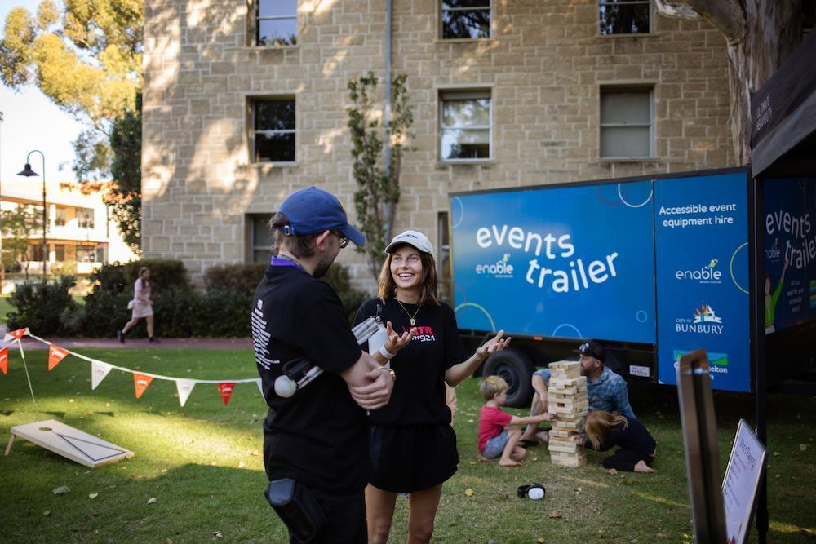
Theme 5: Accessible physical design and environment

Objectives:
- Improve access to the station, which is currently on the first floor of a building that is only accessible via two staircases (due to financial constraints of RTRFM’s fundraising scope).
- Ensure events and all other off-site RTRFM activities are accessible and accommodate the needs of people with disability.

Actions:
- Present blueprints for more accessible RTRFM studio space, with DIAG feedback considered, for funding pitches to state government and other philanthropic bodies.
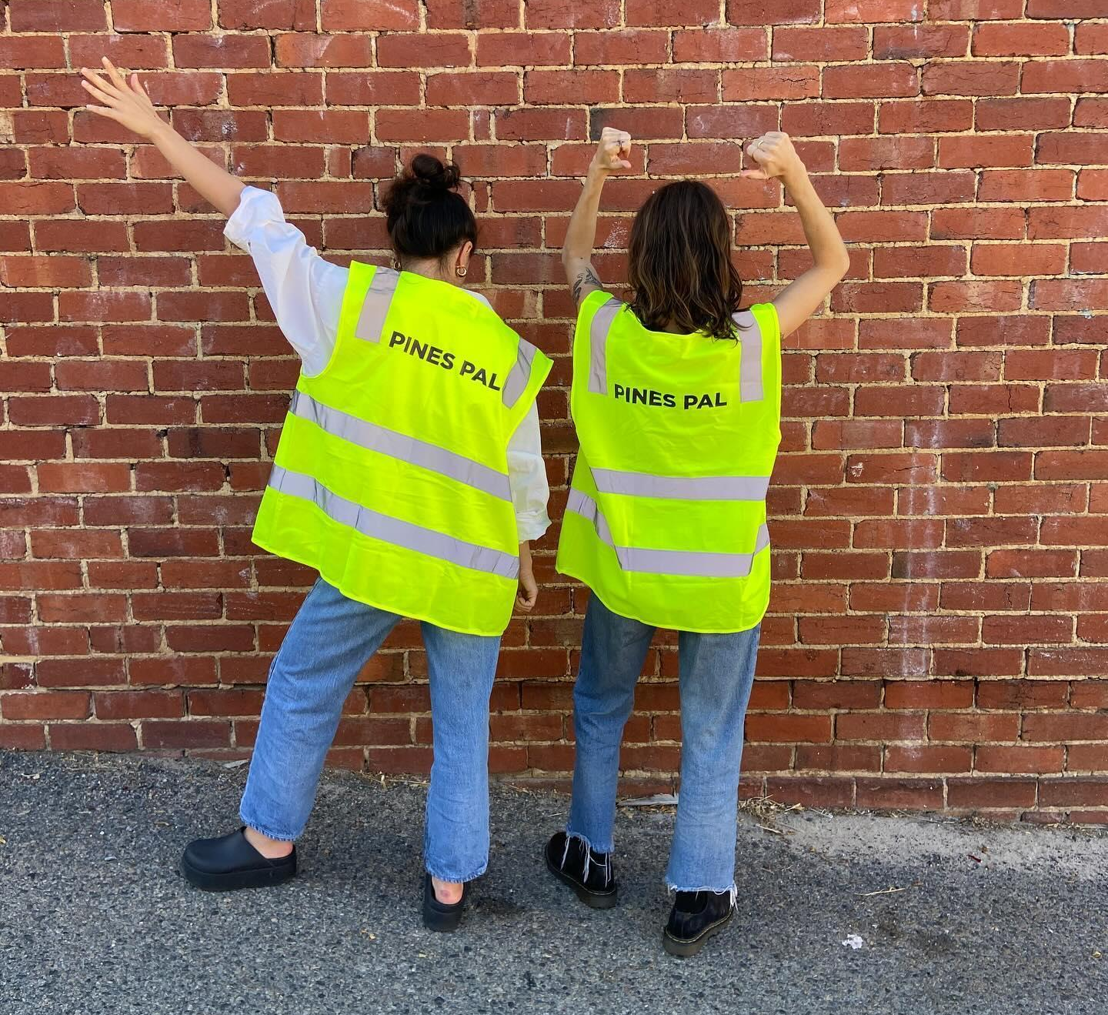
- Provide guidance/training for presenters with disability to remote broadcast from touchscreen desks.
- Seek consistent Breaking Sound Barriers training funding.
- Maintain and expand Pines Pals / Sensory Space at In the Pines to other events.

Time Frame:
- Q2 2027 - ongoing

Definitions

Accessible: Able to be reached, entered or utilised by all people.
Co-Design: A collaborative approach to developing plans or programs that directly include the contributions of those with diverse and lived experience who will be affected most. In this context, it means RTRFM staff working with the DIAG on the Disability Inclusion Plan before presenting it to the RTRFM Board for approval and implementation.
Community Engagement: Includes and refers to a planned process where stakeholders and communities share and exchange information to inform, make decisions and take action to solve problems or overcome issues.
Community: Includes and refers to any group of people who share a similar interest, affiliation, identity, geographical location or place.
Disability: This includes people with physical, intellectual, psychiatric, sensory, neurological and learning disabilities. It also includes physical disfigurement and the presence in the body of disease-causing organisms, such as the HIV virus. It covers disabilities that people have now, had in the past, may have in the future or which they are believed to have. (Disability Discrimination Act)
Disability Awareness Training: Courses that provide education in the accessibility space. These courses should be accredited or be delivered by a suitably qualified organisation.
Easy Read: Documents or communication methods that use simple language, large text, clear layouts and visual aids to make information accessible to people with reading difficulties. RTRFM uses outlines produced by Developmental Disability WA for guidance.
Stakeholder: Includes and refers to an individual, a group of individuals or organisations that have an interest in an outcome or impact of an issue and/or decision.

Australian Bureau of Statistics. (2018). Disability, Ageing and Carers, Australia: Summary of Findings. Retrieved from: https://www.abs.gov.au/statistics/health/disability/disability-ageing-and-carers-australia-summary-findings/2018
Vic Health. (2014). Enabling Health: Taking action to improve the health of people with a disability. Retrieved from: https://www.vichealth.vic.gov.au/media-and-resources/publications/enabling-health
Wilson, E., & Jenkins, E. (2009). Inclusion: making it happen. Key elements for disability organisations to facilitate inclusion. Retrieved from: https://www.scopeaust.org.au/uploads/documents/Research-project-summary-reports/Inclusion-making-it-happen-report-1.pdf
Pope, J., Doyle, S., & Victoria. Department for Victorian Communities. Strategic Policy and Research Division. (2006). Strengthening local communities : arts in community settings : the evaluation of two community support funded arts programs. Retried from: https://find.slv.vic.gov.au/permalink/61SLV_INST/1dukq3j/alma9914332953607636

