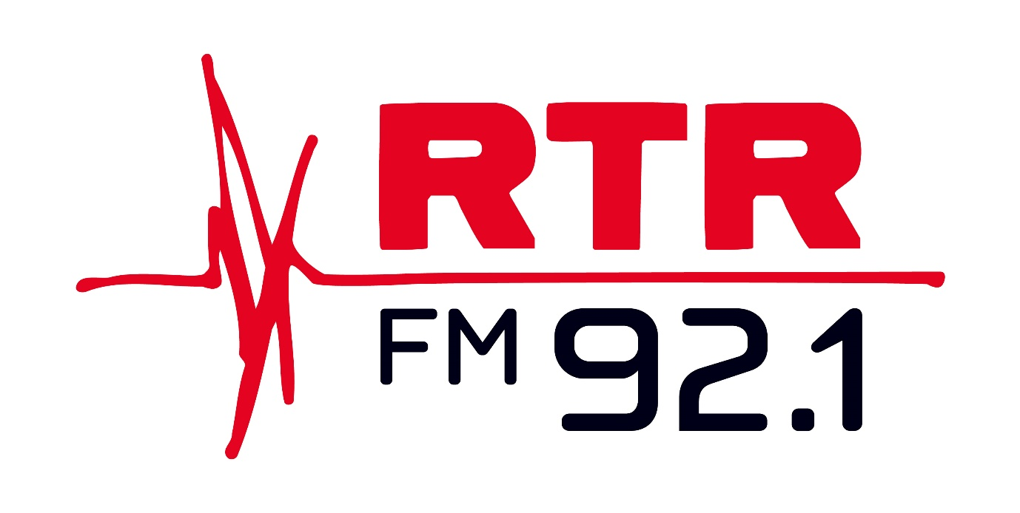

Disability Inclusion Plan

2022 - 2024

This Plan is available in the following alternative formats:

* Large print (PDF and Word versions)
* Easy English document (PDF and Word versions)
* Audio

# Why this matters to RTRFM

"RTRFM is a strong advocate for inclusion, human rights and social justice and this commitment is part of a foundation that guides how we do business. It is important to us that anyone can safely participate in all that we do and feel that they belong."

General Manager Simon Miraudo.

Despite strong anti-discrimination laws in place, people with disability are among the most marginalised groups in our community and experience multiple forms of discrimination and exclusion.[1] [2]

The role of allies and organisations with voice and influence, such as RTRFM, can be essential to help reduce barriers and experiences of discrimination, providing meaningful opportunities to participate fully in mainstream environments.[3]

RTRFM is proud to have established a strong reputation within Western Australia and has been striving to create a diverse community of passionate music and arts lovers for more than 45 years.

With more than 99,000 weekly listeners, the station has successfully created a welcoming and inclusive community with a focus on arts, culture, social justice, politics and the environment. It acts as an advocate and voice for marginalised people, and this Plan represents this commitment to make sure there is greater participation and engagement from people with disability in all that RTRFM does.

# Our journey so far

In late 2021, RTRFM formed the [Disability Inclusion Advisory Group (DIAG)](https://artsradioltdtartrfm921.cmail19.com/t/r-i-tyhytudy-l-t/) to help guide the station, programming and events in its efforts to become even more inclusive and accessible. This coincided with the launch of the Community Broadcasting Association of Australia award-winning [Breaking Sound Barriers](https://artsradioltdtartrfm921.cmail19.com/t/r-i-tyhytudy-l-i/) initiative, providing podcasting and broadcasting training to people with disability.

Since then, the station has implemented many actions contained in the plan including:

* Promoting free entry to RTRFM events for Companion Card holders;
* prioritising disability access at live music fundraisers; and
* including captioning on our published videos.

# Our Plan

The Disability Inclusion Plan (DIP) is one of the first major outputs of the foundational DIAG, having been developed through a co-design approach, following engagement and consultation with the broader community (specifically those with disability as well as disability-involving organisations).

This engagement aims to connect RTRFM with the disability community, increasing awareness of RTRFM as well as informing and collaborating on the design and implementation of actions contained in the DIP. As an outcome, we strive for an increase in people with disability participating in all that RTRFM does.

The Plan is intended to act a living document that will be adjusted and amended based upon ongoing feedback, engagement and consultation. It will provide a practical roadmap towards improved inclusion and accessibility at RTRFM, informing the station’s Strategic Plan to ensure the station continues its mission to be a welcoming and respectful radio station, especially for people with disability/disabilities.

RTRFM thanks the DIAG for their work and support thus far, as well as key collaborator For Inclusion Consulting, and we thank the wider public for their patience and collaboration as we aim to make our community ever more accepting.

Disability Inclusion Advisory Group members (2022):

Andrew Dewberry   
Anthony Pyle (Carers WA)   
Eleanor Ingram (For Inclusion Consulting)  
James Fabri (RTRFM)  
Jason and Lou Bodle   
Jayde Baldock   
Kailyn Crabbe (RTRFM)   
Kat Tan (Youth Disability Advisory Network)   
Lauren Curtis (RTRFM)   
Maxine Drake (Developmental Disability WA)   
Patrick Marlborough   
Sarah Arnason (MOSAIC)  
Simon Chong (People with Disability WA)   
Siyat Abdi (Kin Advocacy)

Tom Reynolds (RTRFM)

Disability Inclusion Advisory Group members (2023):

Anthony Pyle (Carers WA)

Alana Hunt (RTRFM)  
Claire Pannell

Eleanor Ingram (For Inclusion Consulting)  
Jason and Lou Bodle

Jane Armstrong (RTRFM)

Jess Carlton

Joss Morgan  
Kat Tan (Youth Disability Advisory Network)

Kelly Campbell

Kristyanne Rung  
Joseph Wilkie (Bus Stop Films)   
Julia Bak

Maxine Drake (Developmental Disability WA)   
Simon Chong (People with Disability WA)

## Theme 1: Open and respectful environment

Objectives:

* Increase the representation of volunteers, presenters and staff with disability at RTRFM.
* Champion local music, safe spaces and support of musical diversity.

Actions:

* Connect with the community and establish a Disability Inclusion Advisory Group (DIAG).
* Provide transparent and regular reporting on DIAG’s progress to the RTRFM Board.
* Create Disability Inclusion Plan (DIP), set targets for representation and encourage people with disability to participate in RTRFM.
* Advertise and promote roles/support available.
* Promote inclusion and diversity of people with disability in the arts and music community.

Time Frame:

* Q2 2022

## Theme 2: Accessible and easy to read information

Objectives:

* Accessible websites.
* 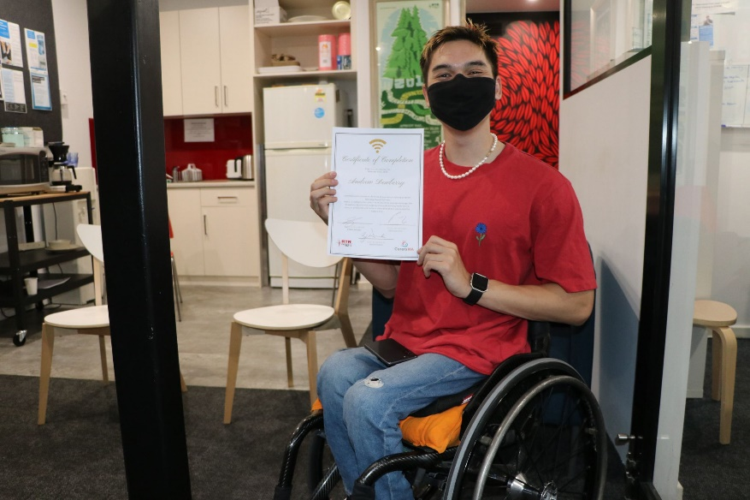Information available in alternative formats.

Actions:

* Update websites to minimum level: WCGA AA.
* Key documents and publications are available in plain English, and in alternative formats (word, PDF, alt text for images).

Time Frame:

* Q4 2022 - ongoing

## Theme 3: Disability awareness

Objectives:

* Improve awareness, understanding of people with disability.
* Increase confidence among staff on how to provide support to people with disability.
* Improve visibility of artists/performers/musicians with disability.

Actions:

* Disability awareness training for staff and volunteers.
* Continue delivering content, via shows, that raise awareness of people with disability.
* Showcase artists/performers/musicians with disability.
* Include additional (and optional) fields to capture disability on forms such a member surveys and volunteer applications.
* Offer peer support program where volunteers are paired with people with disabilities for events, et cetera.
* Highlight and promote local events related to or inclusive of disability.

Time Frame:

* Current - ongoing

## Theme 4: Supportive and friendly attitude

Objectives:

* Increase engagement with people with disability.
* Build and maintain relationships with people with disability.
* Monitor, track and seek out feedback.

Actions:

* Provide opportunity to listen and hear feedback from people with disability and broader community (introduce feedback/complaints mechanisms).
* Connecting with and engaging key disability stakeholders.
* Develop and implement disability inclusion policy/guidelines.
* Capture (optional) information on performers/artists with disability for RTFRM and AMRAP music playlist database, to increase awareness of and improve reporting on representation.

Time Frame:

* Q1 2023

A sign on a fence at RTRFM's annual local music event that says "Ask about Pines Pals". Pines Pals are available to support those who identify across a range of disabilities.


## Theme 5: Accessible physical design and environment

Objectives:

* Improve access to the station.
* Ensure events are accessible and accommodate the needs of people with disability.

Actions:

* Assess and identify opportunities to improve physical access to the station, and continue pursuing alternative arrangements with other stations.
* Introduce remote and flexible radio presenting as a standardised accommodation.
* Curated space on the RTRFM website to promote content (podcasts/shows etc.) developed by people with disability.
* Introduce further procedures to accommodate needs of people with disability at events: e.g. Auslan Interpreter; wheelchair access; include in promotional materials; consult and include people with disability in the planning process; identify and use accessible venues as much as possible; accessible and easy to use booking process; ‘Pines Pals’.

Time Frame:

* Q2 2023

A diverse crowd of people including wheelchair users, at RTRFM's annual outdoor local music event In the Pines.



# Definitions

Community Engagement:

Includes and refers to a planned process where stakeholders and communities share and exchange information to inform, make decisions and take action to solve problems or overcome issues.

Community: Includes and refers to any group of people who share a similar interest, affiliation or identity, geographical location or place.

Stakeholder: Includes and refers to an individual, a group of individuals or organisations that have an interest in an outcome or impact of an issue and/or decision.

Disability: This includes people with physical, intellectual, psychiatric, sensory, neurological and learning disabilities. It also includes physical disfigurement and the presence in the body of disease-causing organisms, such as the HIV virus. It covers disabilities that people have now, had in the past, may have in the future or which they are believed to have. (Disability Discrimination Act)

# References

1. Australian Bureau of Statistics. (2018). Disability, Ageing and Carers, Australia: Summary of Findings. Retrieved from: https://www.abs.gov.au/statistics/health/disability/disability-ageing-and-carers-australia-summary-findings/2018
2. Vic Health. (2014). Enabling Health: Taking action to improve the health of people with a disability. Retrieved from: https://www.vichealth.vic.gov.au/media-and-resources/publications/enabling-health
3. Wilson, E., & Jenkins, E. (2009). Inclusion: making it happen. Key elements for disability organisations to facilitate inclusion. Retrieved from: http://www.scopevic.org.au/wp-content/uploads/2015/02/Inclusion-making-it-happen-report.pdf

   # Contact details

   # Email: DIAG@rtrfm.com.au

   **Phone: 08 9260 9213**